# Creating Horizontal Partitions in SQL

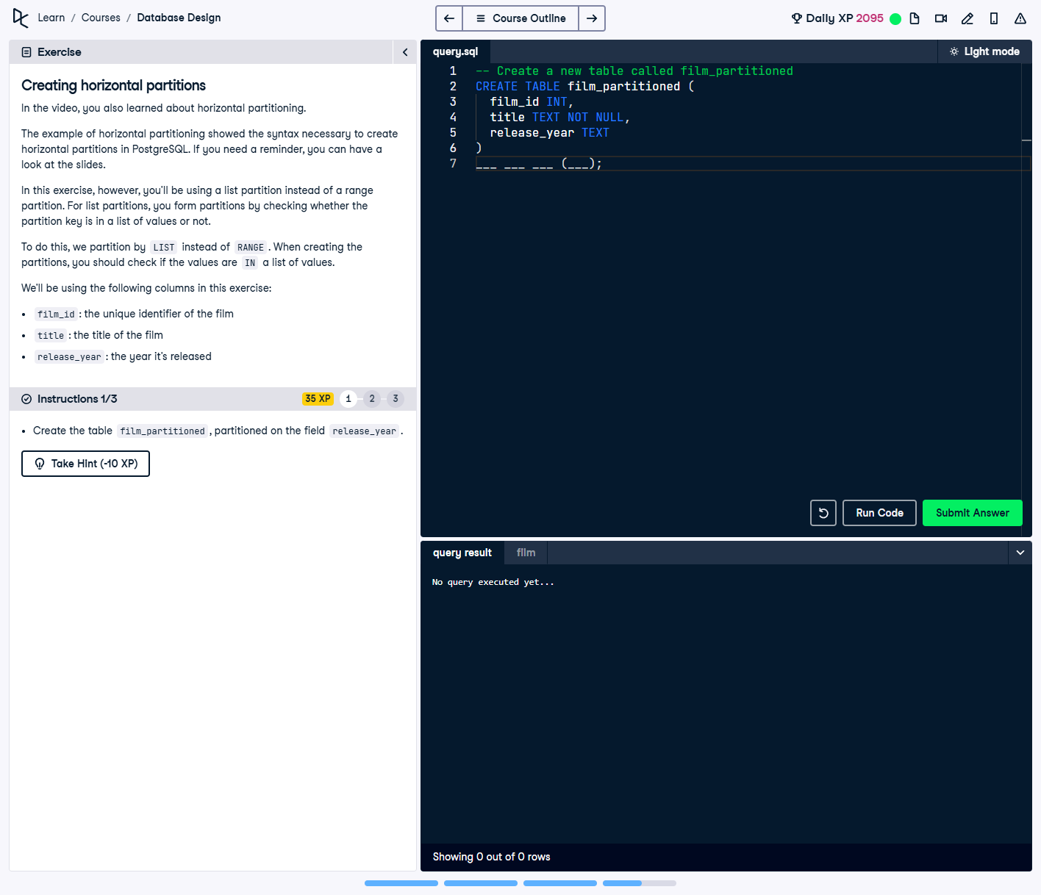

## Question:

In this exercise, you need to create a table `film_partitioned`, partitioned on the field `release_year`. You'll be using **list partitioning**, where data is divided based on a predefined list of values.

## Full Answer (SQL Code):

-- Create a new partitioned table called film_partitioned  
CREATE TABLE film_partitioned (  
 film_id INT,  
 title TEXT NOT NULL,  
 release_year TEXT  
) PARTITION BY LIST (release_year);  
  
-- Create partitions for specific years  
CREATE TABLE film_2020 PARTITION OF film_partitioned FOR VALUES IN ('2020');  
CREATE TABLE film_2021 PARTITION OF film_partitioned FOR VALUES IN ('2021');  
CREATE TABLE film_other PARTITION OF film_partitioned DEFAULT;

## Explanation of the Answer:

The `CREATE TABLE` statement defines `film_partitioned` as a partitioned table using `LIST` partitioning on `release_year`. Partitions `film_2020` and `film_2021` store data for specific years, while `film_other` handles any remaining values not explicitly listed.